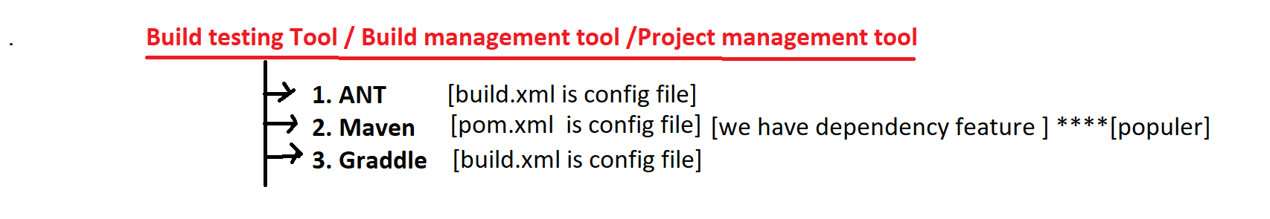

1. **Why maven is required in Development?**

its build testing/

management tool used for build creation & testing & deployment

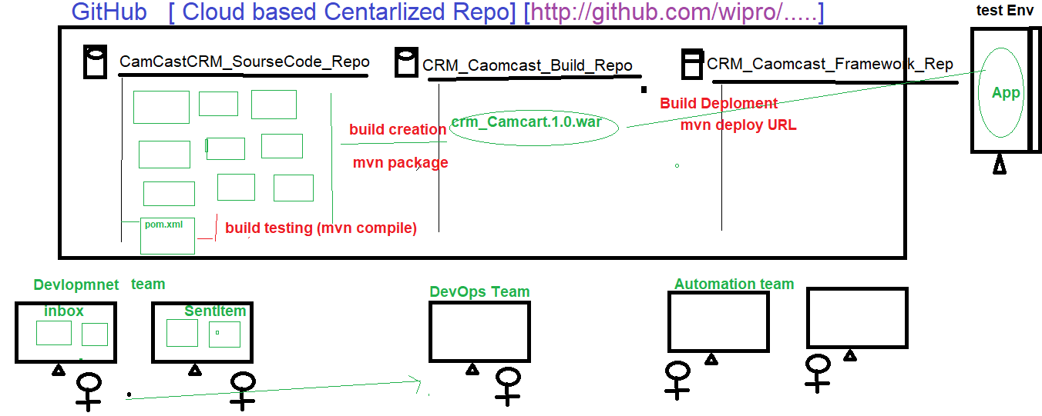

Build testing: maven used to check the compilation & integration issue between the source Code, when multiple developers working with same application.

Build creation/Process: process of converting source code format in to executable format is called build creation (mvn package)

Build Deployment: deploy the executable file in to server is called build deployment process(mvn deploy & mvn install).

1. **Why Maven in Automation.**

It’s build testing tool, which is used to check the integration & Compilations issues between the framework component, whenever one users done the modification, addition deletion happened in the framework

-> When multiple engineers working with the same framework, there might be chances one engineer modification might affect entire framework, in order to resolve/check this kind issue we go for Maven

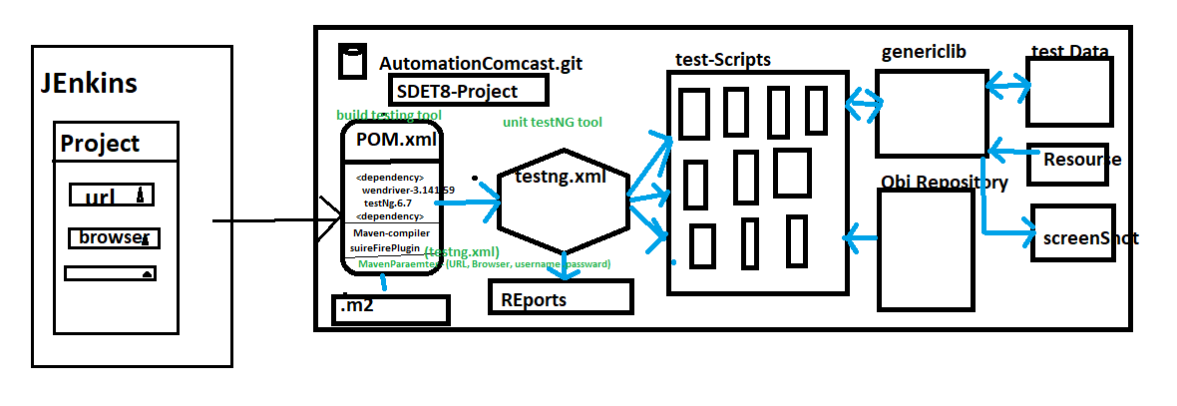

1. **Advantages of Maven**
2. Check the integration & compilation issue between the framework component whenever modification, addition deletion happened in the framework
3. handle dependencies jars
4. create framework configuration quick setup for new engineers (because all the required dependencies jar. Versions declared in POM.xml, you just to get the framework from github & run the POM(Update Maven Project) /CMD>mvn test)
5. create framework folder structure
6. we can run the test script in command Line without Eclipse
7. Which is used to check framework build broken or not ?
8. Maven majorly support in Jenkins for CD/CI [Jenkins]
9. Maven also support Profiling (whenever we have multiple testing.xml file in one POM.xml, in-order to execute specific xml testing.xml file in CMD prompt , we go for profiling
10. Maven Also support run time maven parameter

EG : CMD > -Dusername=admin –Dpassword=password

1. **What all the Maven Software required to handle maven Project in real time?**

* Two software available in Maven

🡺Maven Ellipse Plugin

🡺Maven Command Line Plugin

1. 🡺Maven Eclipse Plugin : it’s a default plugin available in Eclipse Ide , used to create project in Eclipse

Eclipse🡺new 🡺Project🡺Maven🡺MavenProject🡺 Enter GroupId &artifactID🡺Finish

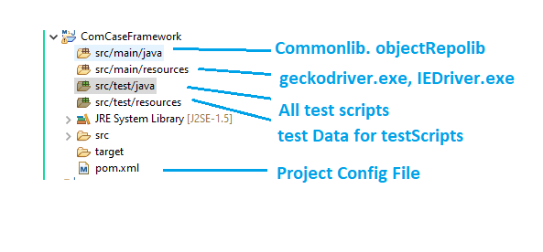

🡺Maven Command Line Plugin : it’s should be installed explicitly in all local computers , used to handle the Maven project in CMD line

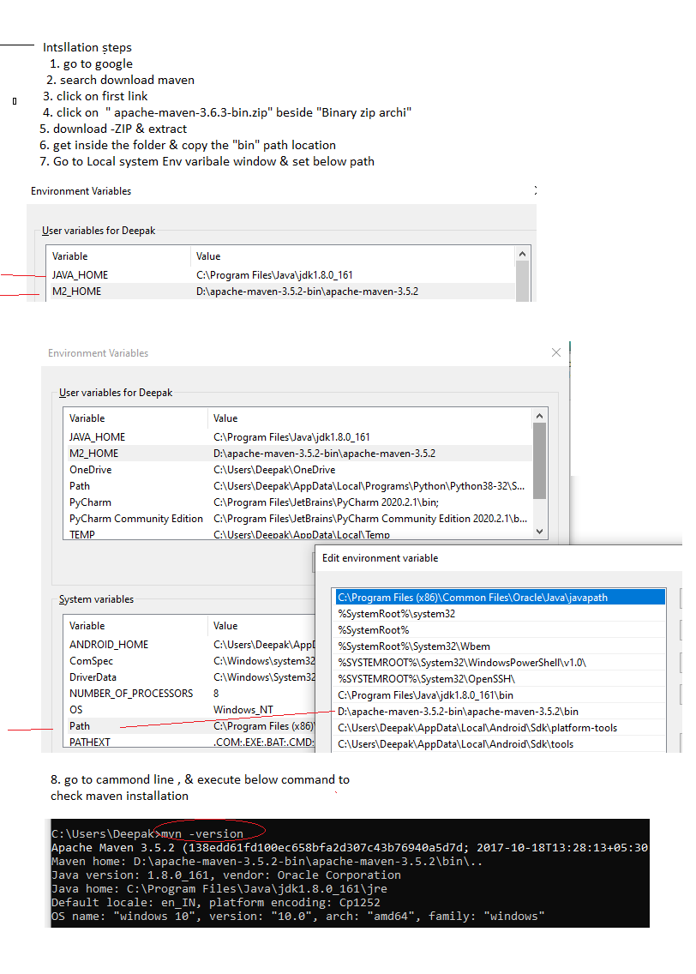

1. What is Maven Dependency & how to handle?

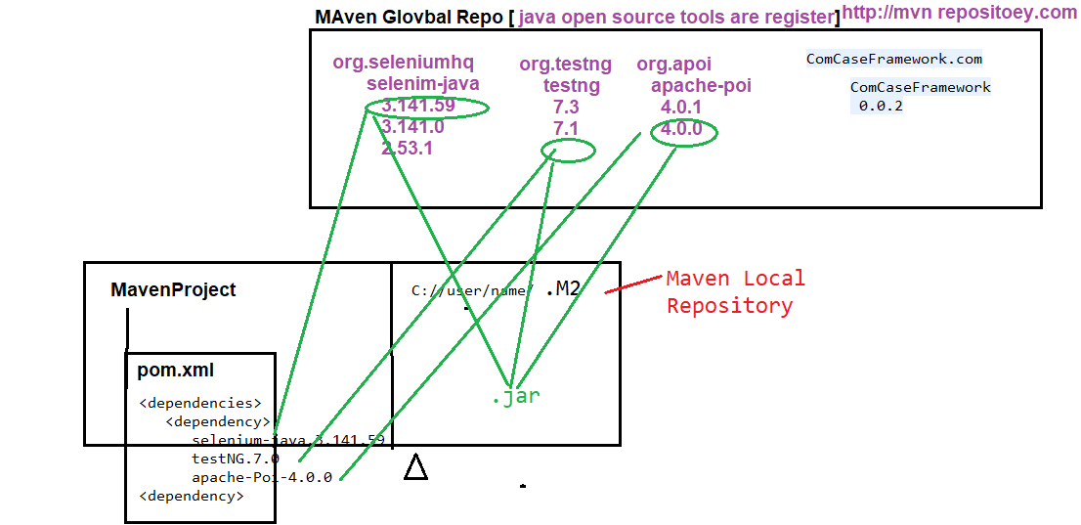

Dependency is a feature available in maven tool, which used to get/download required Jar’s files from Global-Repository(http://mvnrepository.com) to Local-Repository (.M2 folder C://user/name/.m2)

To handle Maven Dependency fallow below steps

1. Create maven Project
2. Go to POM.xml [Project Object Model] file inside the Maven Project
3. Edit POM.xml
4. Add below Tag

<dependencies>

</ dependencies >

1. Go to GlobalRepository [http://mvnrepository.com], search for the required tool like selenium-java , testing etc
2. Copy the dependency code

EG:

<dependency>

<groupId>org.testng</groupId>

<artifactId>testng</artifactId>

<version>7.1.0</version>

<scope>test</scope>

</dependency>

1. Paste the dependency code inside the POm.xml
2. Save the file

What is gropuId & artifactID

gropuId 🡺 name of the community/ Organization

artifctID 🡺 name of the Project

1. **How to execute test in CMD**
2. Project🡺 RightClick🡺 Properies 🡺 copy the Project location

EG : C:\Users\Deepak\eclipse-workspace\ComCaseFramework

1. Open CMD

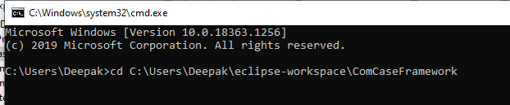

1. Execute Maven commands
2. **Explain maven Build Life Cylcle / maven Commands**

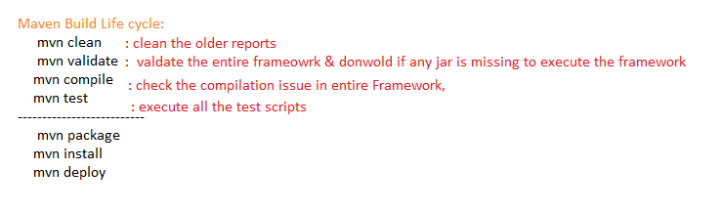

**How to execute only one test using maven Cmd**

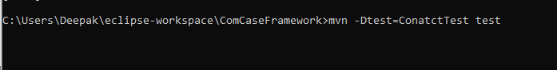

What is Maven Profiling ?

When Framework contains multiple testing.xml files, inOrder to execute particular testing.xml via POM.xml file , we go for profiling



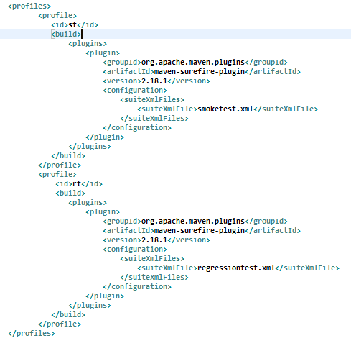

How to execute TestNG.xml via POM.xml

To execute testing.xml via POM.xml , we should include “maven-sureFire-plugin” In side the POM.xml

<build>

<plugins>

<plugin>

<groupId>org.apache.maven.plugins</groupId>

<artifactId>maven-surefire-plugin</artifactId>

<version>2.18.1</version>

<configuration>

<suiteXmlFiles>

<suiteXmlFile>testng.xml</suiteXmlFile>

</suiteXmlFiles>

</configuration>

</plugin>

</plugins>

</build>

What is Maven Parameter

Using Maven Parameter we can pass the data from the command line in run Time



Pass maven Parameter from the Eclipse

Select-TestNGFile🡺 Right Click🡺 Run As🡺 Run Configuration 🡺 Arguments

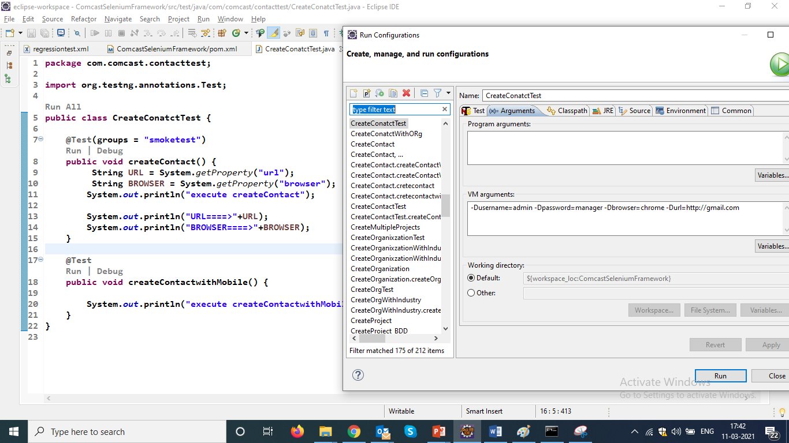

**When We execute MavenFramework in command line , where html report will be generated ?**

Yes, report will be generated inside the **target** folder in below location

🡺Go eclipse =>refresh the Project🡺 target 🡺 sureFire-reports🡺 emialable-Report.html